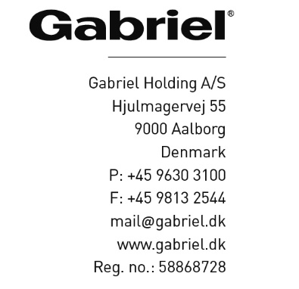

Aalborg, May 1st 2023

Gabriel Code of conduct and UN Global compact

Gabriel continuously works to build and maintain a strong ethical business culture throughout the entire Group. Gabriel’s Code of Conduct and Supplier Code of Conduct set standards for the way, we do business and incorporate the internationally accepted UN practices and standards. Our ethical codices include human rights, animal welfare, anti-corruption, and anti-bribery.
Gabriel is a UN Global Compact participant and a member of UN Global Compact Network Denmark. By endorsing the ten principles of the UN Global Compact, Gabriel is committed to continuously strengthen its social responsibility and to contribute to the UN Sustainable Development Goals.

Kurt Nedergaard
Director of CSR and Quality
Gabriel Holding A/S

